Unemployment Analysis using tableau

Using Horizontal Bars, We plotted The total unemployment rate in USA with California having the highest unemployment rate and Wyoming with the lowest

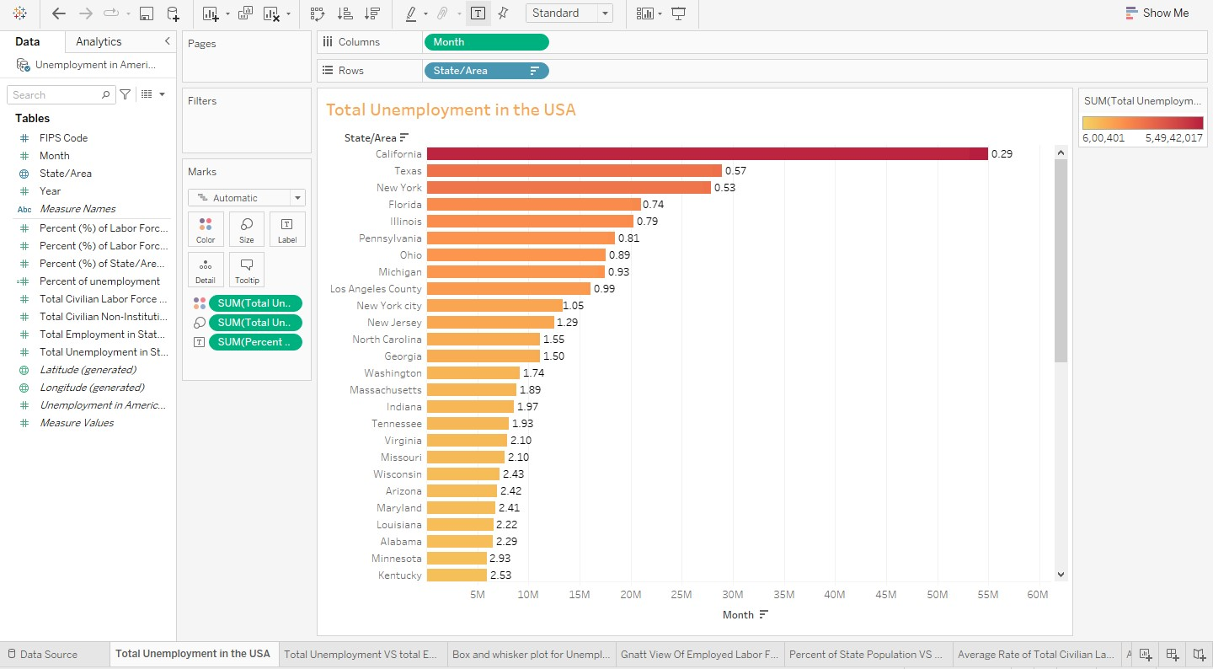

We plotted The total unemployment rate VS Total employment in USA with California having the highest unemployment rate and Wyoming with the lowest

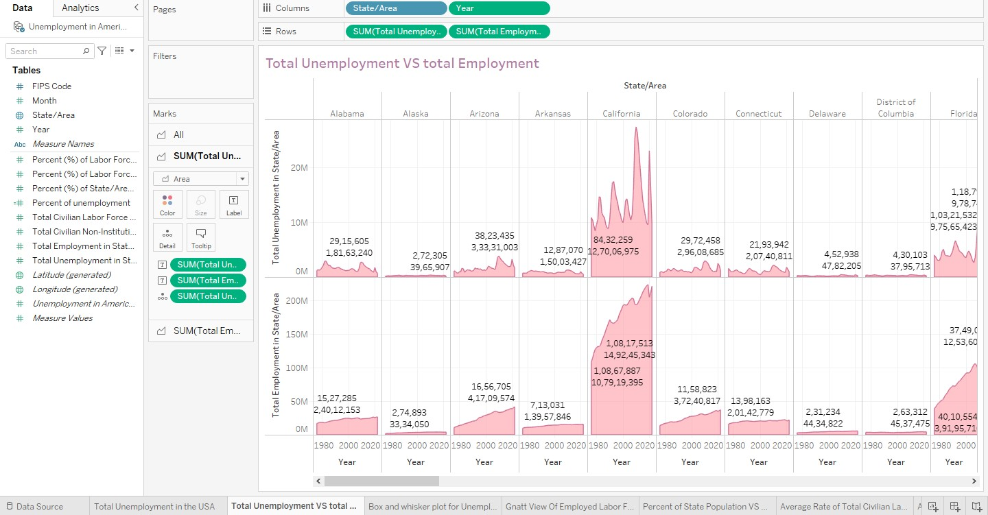

The percentage of the labor force that is unemployed in a specific state or area is a crucial economic indicator reflecting the health of the job market in that particular region. This percentage is highest in West Virginia and lowest in South Dakota

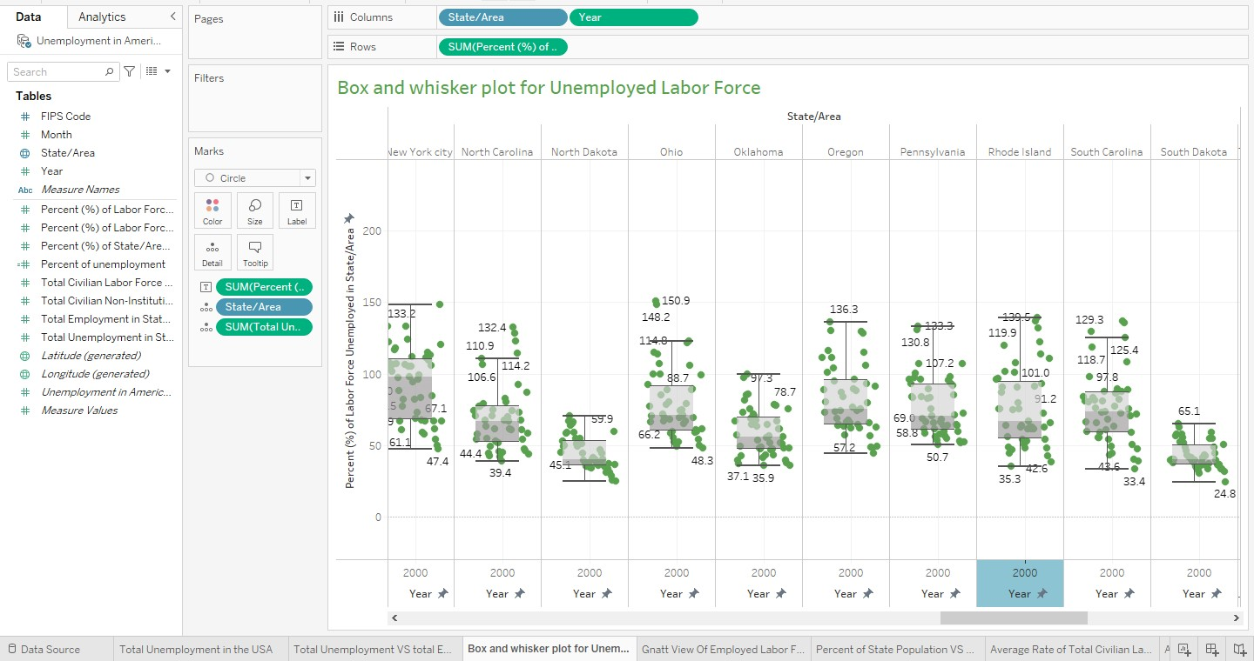

The percentage of the labor force that is employed in a specific state or area is another vital economic indicator that provides insights into the health of the job market in that region. Similar to the unemployment rate, it's calculated by dividing the number of employed individuals by the total labor force and then multiplying by 100 to express it as a percentage.

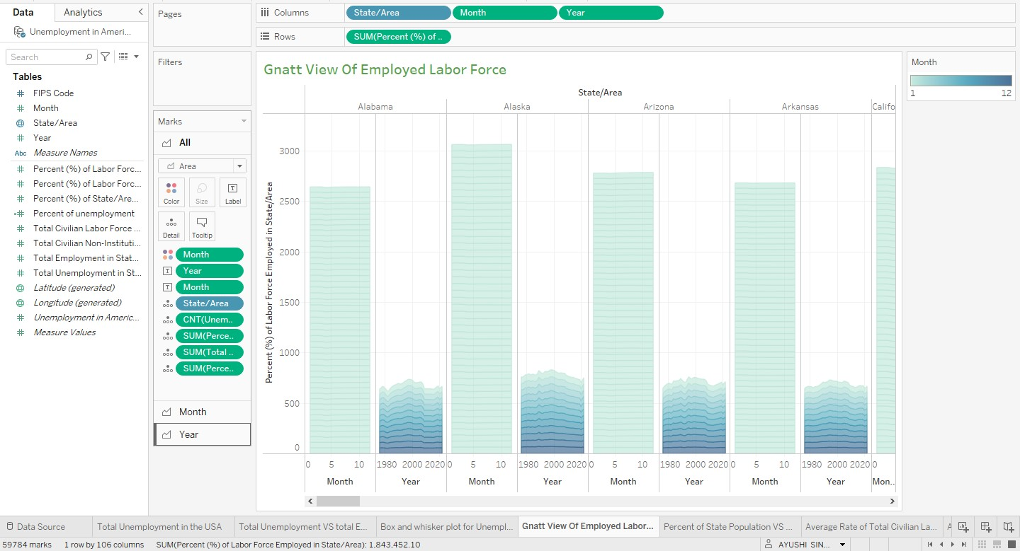

The percentage of the state population versus the average unemployment rate refers to the relationship between the total population of a state and the average rate of unemployment within that state. With highest in California and lowest in North Dakota

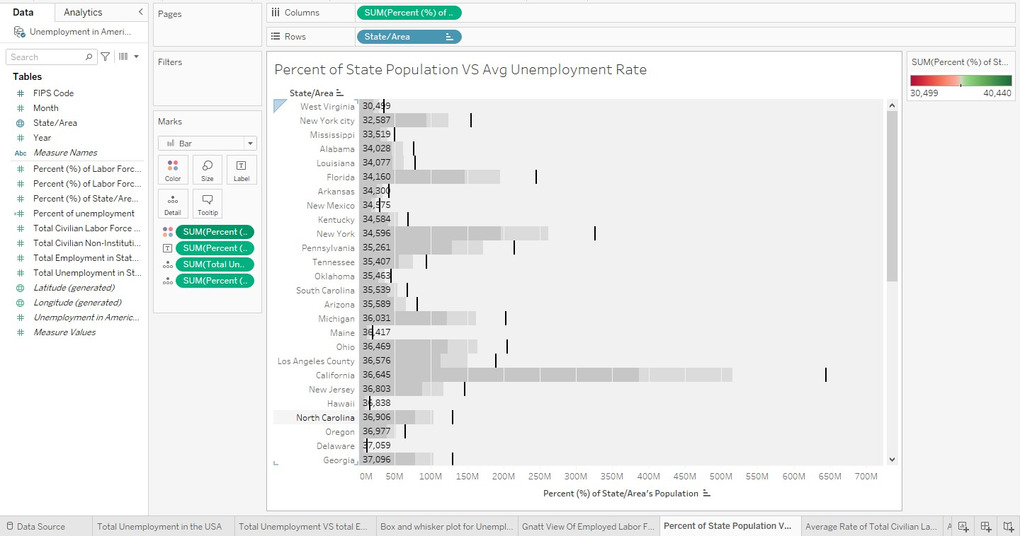

The average rate of the total civilian labor force refers to the mean percentage of individuals who are part of the civilian labor force over a specified period

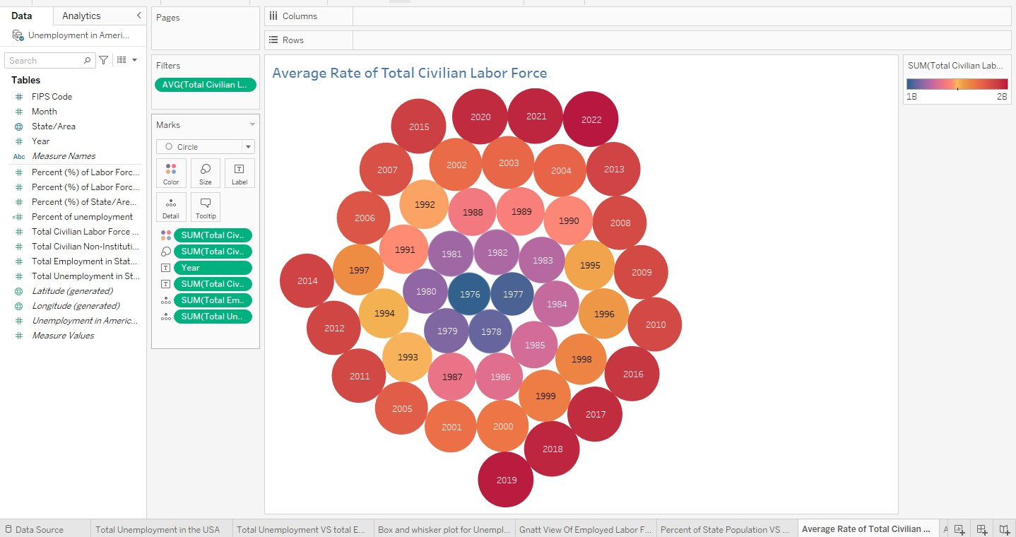

The average and total civilian non-institutional population in a state are essential demographic measures used to understand the size and composition of the population eligible to participate in the labor force and other societal activities. This refers to the portion of the population that is not residing in institutions such as correctional facilities, mental health facilities, nursing homes, or longterm care facilities. With highest in California and Lowest in Wyoming

